**Assignment 3.2**

**Problem Statement 1:**

Create a file with the name max-temp.txt in the local file system and add 10-15 records with two columns for date and temperature and save it as max-temp.txt Example: dd-mm-yyyy, temperature

* 10-01-1990, 10
* 10-02-1991, 20

**Output:**

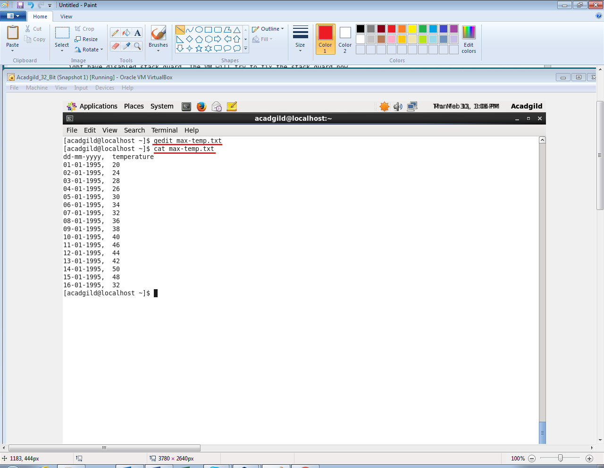

**Problem Statement 2:**

Copy the above max-temp.txt file from the local file system to HDFS in the /user/acadgild/hadoop path.

**Output:**

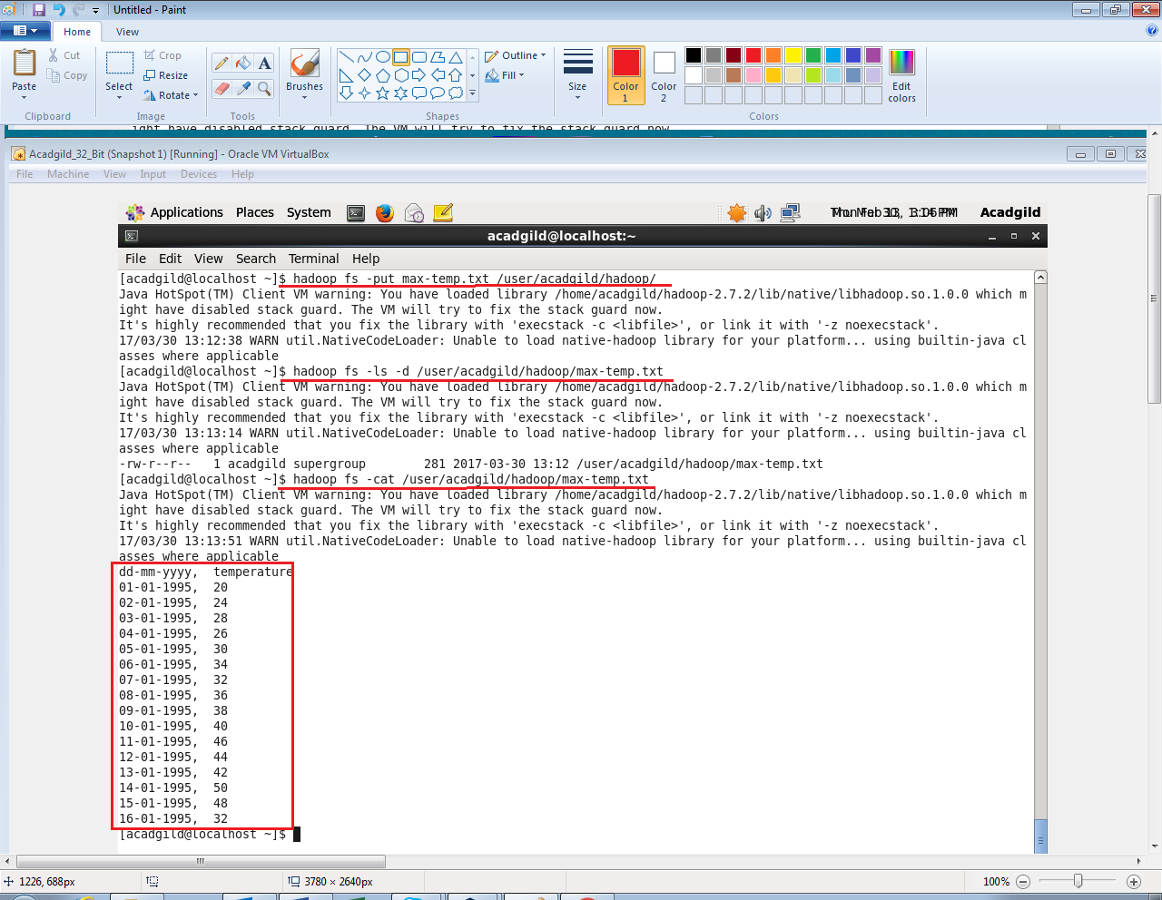

**Problem Statement 3:**

Change the permission of the file /user/acadgild/hadoop/max-temp.txt, such that only the owner and the group members should have the r-w-x permissions. Others should have only read the permission on the above file.

**Output:**

